

User guide

Hardware and Software Requirements
Before you attempt to utilise the system, ensure that the following requirements are met on the workstation on which the system will be executed. These are considered the minimum specifications, and as such any problems caused by hardware or software issues cannot be attributed to the program if they occur.

If you are unsure of your system’s specification, please contact the administrator or an IT specialist.

Software requirements:
- Operating system:
  - Windows 10 or later (64-bit)
  - OR Windows Server
- Runtime/framework
  - .NET 8 (Windows Desktop Runtime)
- Dependencies
  - Microsoft SQL Server
  - Visual Studio 2019
  - Relevant NuGet packages (refer to Visual Studio 2019’s documentation)
Hardware requirements:
- Minimum:
  - Dual-core 1.6 GHz CPU
  - 4GB RAM
  - 500MB-2GB free disk space
  - 1366x768 resolution display
  - Stable LAN connection
- Recommended:
  - Intel i5/Ryzen 5 or equivalent
  - 8GB+ RAM
  - 2-5GB free SSD disk space
  - 1920x1080 resolution display

Installation
Before you begin utilising the system, it is crucial that you have the appropriate program files present on your workstation. As a prerequisite, ensure that you have the software system’s project’s files present in a readily accessible folder. If you do not, please consult an IT specialist or administrator regarding access to these files.

Compilation
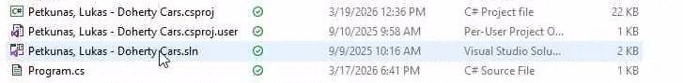
- With the project folder open, find the solution file and open it in Visual Studio 2019. This will open the project and attempt to load all of its files. Before attempting to compile, ensure that all necessary files have been loaded, especially if you rely on a cloud-based storage solution such as OneDrive.
- From here, locate the section in the toolbar with the button labelled “Start.” Beside this should be a list from which you can select compilation methods. For standard usage, select “Release” before proceeding.
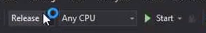
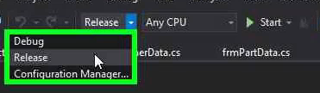
- After selecting the desired compilation method, go to the “Build” section in the header and choose the first option.
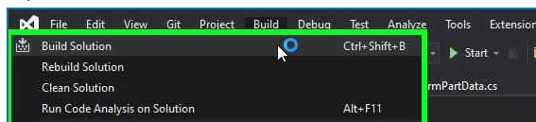
- After this, within the project folder, there will be a “bin” folder. In here, you will be able to enter the folder with the same name as the compilation method you chose (e.g. “Release”) to access the compiled program files. For standard usage, the expected directory is “(project folder)/bin/Release/”

Execution
Within the appropriate folder as described in the “Compilation” section, you will find an executable file with the same name as the project. Double-clicking this will run the system locally.
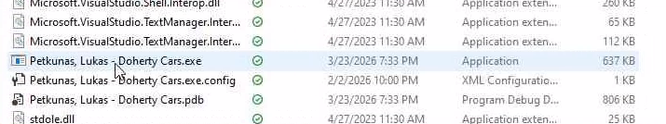

Note that while all the files within the folder are necessary for the program’s execution, the folder need not stay in the same directory. Therefore, once you are finished building, you may move the folder containing the executable to a different location, dispose of the project files and uninstall Visual Studio 2019 if it is unnecessary for you.

If you have any concerns regarding the setup of the program, do not hesitate to contact an administrator or IT specialist.

Operating the system

Logging-in
To log-in, simply input your credentials into the form that initially appears when opening the program, with your username and password in the appropriate fields, and hit “Log-in.” In the event of a successful log-in, you will be redirected to the main menu form. Otherwise, you will be given appropriate feedback. To ensure that you have entered your password correctly, you may avail of the provided “Show Password” checkbox
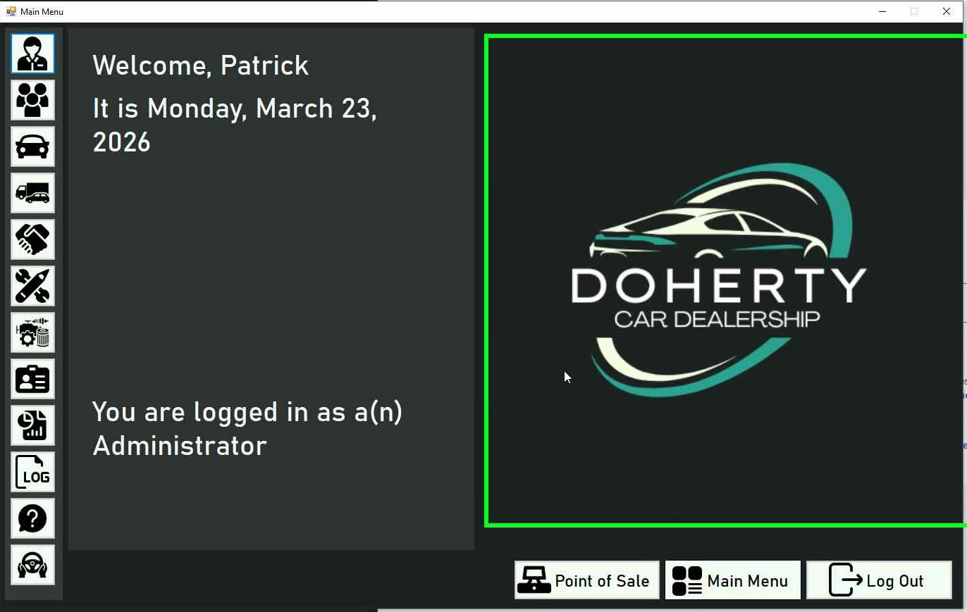




Navigation
Once you have logged in, you will notice unlabelled buttons to the left of the main menu. For more information on them, you may hover over the panel, which will expand the panel and buttons and label the buttons appropriately. If you are not authorised to access a form, the appropriate button will be disabled and made distinctly gray.

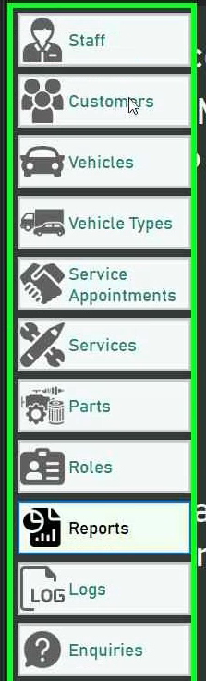
Clicking on any of the buttons will cause their respective form to open in the viewing panel, allowing you to interact with the data stored on the system. If at any point you wish to stop using the system, you may press the “Log Out” button.

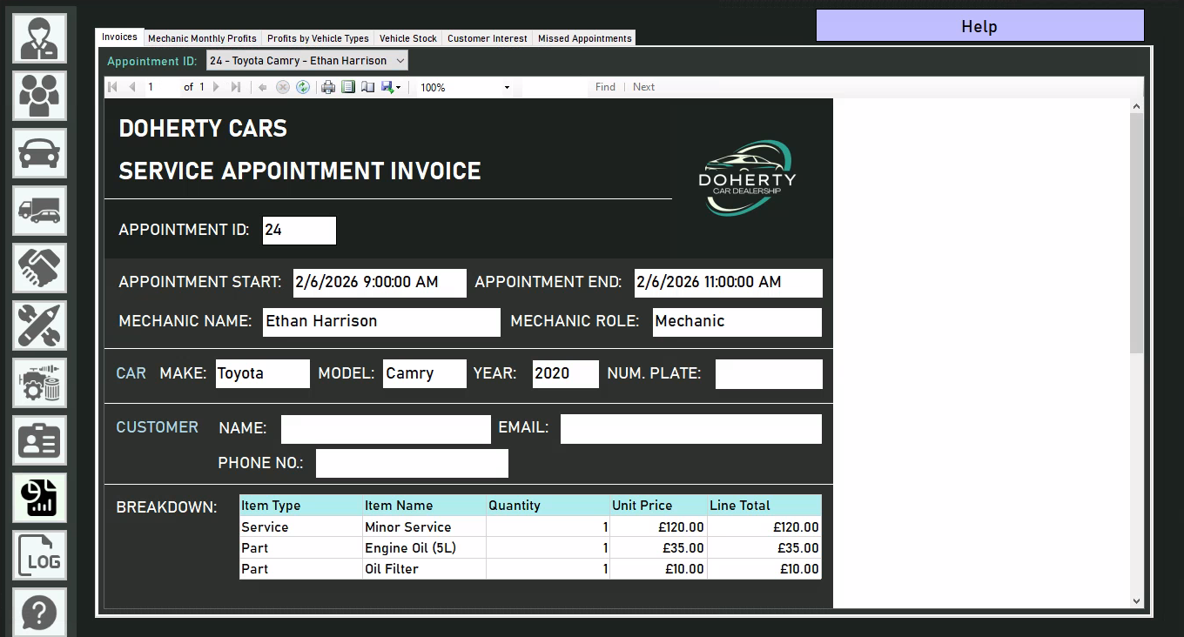

Creating a new user
For the sake of security, no registration form has been provided to prevent unauthorised access to the system. Instead, it is up to administrators (or similarly authorised users) to create user accounts for staff members. First, the administrator must access the system as demonstrated in the previous section.

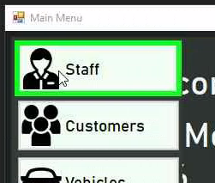
First, access the staff data form.
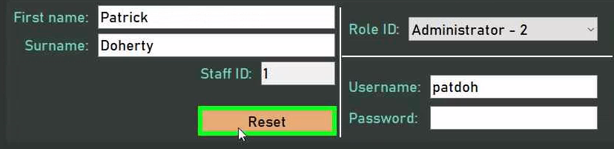
From here, you may find the fields automatically populated. Use the “Reset” button to clear them and make data input easier for you.
Input the new user’s details as appropriate. Make avail of the provided help form if any issues occur during this process. Once you are satisfied with the user details, you may press the “Add” button. This will create a new record with the provided details, and the user will be able to access the system using the credentials you have allocated to them.

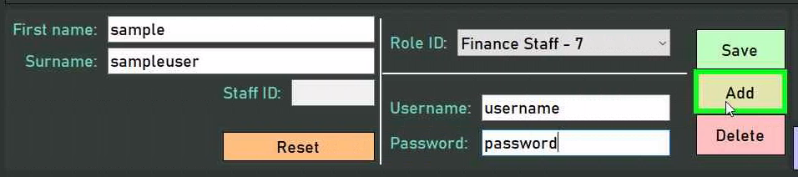

CRUD operations (general)
As 7 of the provided forms use the same general CRUD system (these being the forms for staff, customers, vehicles, vehicle types, parts, services and roles,) much of the behaviour behind these forms carries over and thus each form will not be covered individually. Instead, the most complex of these forms - the vehicles form - will be covered in-depth to allow you to extrapolate the guidance provided onto the other forms.

If you find yourself stuck with any idiosyncrasies of certain forms, do not hesitate to consult the provided help form or - if needs be - an administrator.

Creating
On accessing a form, you may find that details have been automatically populated. To clear the provided fields to prevent you from having to manually delete the populated data, hit the “Reset” button.

From here, you are able to input the desired data for the new record in the provided fields. An attempt has been made to denote the purpose of each field as clearly as possible using a text label to the left of it. Note that every form will have a read-only slot for a record’s ID. When creating a new record, this will be ignored, as the system will automatically handle allocating IDs to new records.

Text fields (such as “Make” and “Model” in this form) can simply be provided by typing in the desired values upon selecting the appropriate TextBox.
Fields that must have restricted values are denoted by ComboBoxes. For fields that simply have a finite number of possible values, these will be determined before the form loads. However, for fields which depend on other tables - in this case, the customers table - all records from those tables will be retrieved, processed and provided as an option in the CheckBox, with pertinent information such as name denoting the record each option in the list represents.
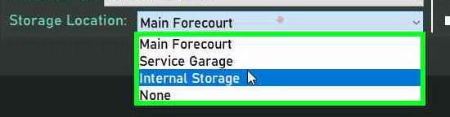
An example of predetermined values
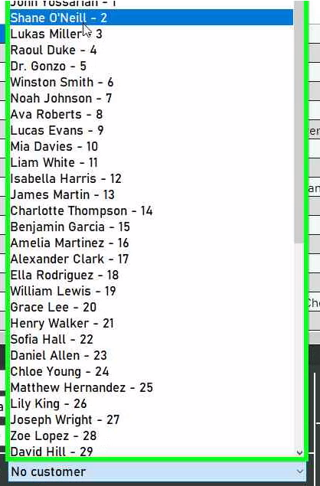
An example of values fetched during runtime

Regardless, to select an option, click on the ComboBox to expand the list, and then click on the desired item in the list.

For numerical data, the NumericUpDown controls provided allow you to either manually go to the number which you desire (using the up and down arrows provided to increase and decrease the value respectively) or simply type in the desired number. Note that they will automatically reject numbers that are either invalid or do not fall within the predetermined ranges.
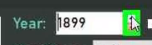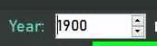
Lastly, for boolean data (that is, anything that is just true or false), CheckBoxes have been provided, which you can tick for “true” and untick for “false.”
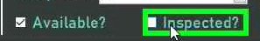

Once you are satisfied with your details, click the “Add” button. This will perform validation on your provided data. If any of the data does not meet the rules enforced by the system, an error message will be displayed and you will be given the chance to amend your provided data. If it is deemed fine, the record will be added to the system, which should be evidenced by its appearance in the table.
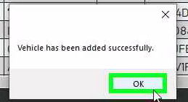
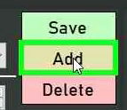

Reading
To select the record which you wish to edit, click on the appropriate row in the table provided. This will select that user for editing or deleting, populating their details into the fields provided.

Note that foreign keys (fields which come from other tables) are identified simply by their ID in the table, but upon selection the appropriate record will be selected in that ID’s ComboBox, allowing you to see which foreign record the selected record is associated with.
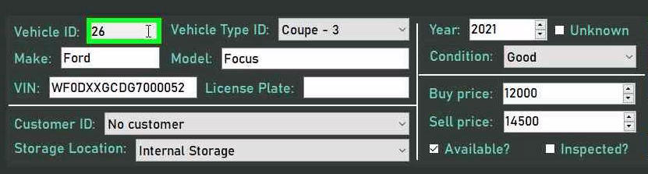

Updating
To update a record, first select the desired record as described in the previous section. Then, with the existing details populated into the appropriate fields, you are able to edit these details (or replace them with entirely new ones) with the same procedure described in the “Creating” section.

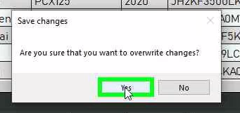
Once you are satisfied with your input details, click on the “Save” button. Your data will be validated, and if it passes the checks carried out by the system then the details input will be stored under the same ID as the selected record, as should be evidenced by the presence of new details in the table.
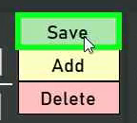

Deleting
To delete a record, simply select it in the table and press the “Delete” button. Note that some forms may have certain rules implemented that could prevent deletion if the record is associated with records in another table, so consult the provided help form to see if these rules apply.
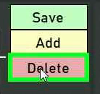
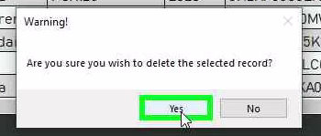

Searching
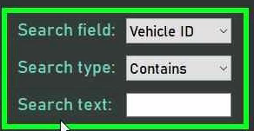
Searching is provided in each CRUD form through the use of 3 controls.
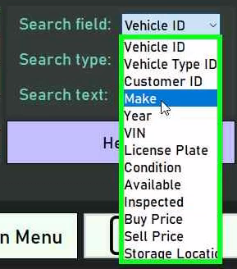
To select the field in the table you wish to search by, select it in the ComboBox.

Similarly, a ComboBox is provided for the type of search, of which there are presently “Contains” - where the provided text can make up part of or the entire field - or “Exact” - where the field must exactly match the provided text.
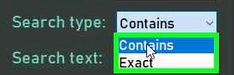
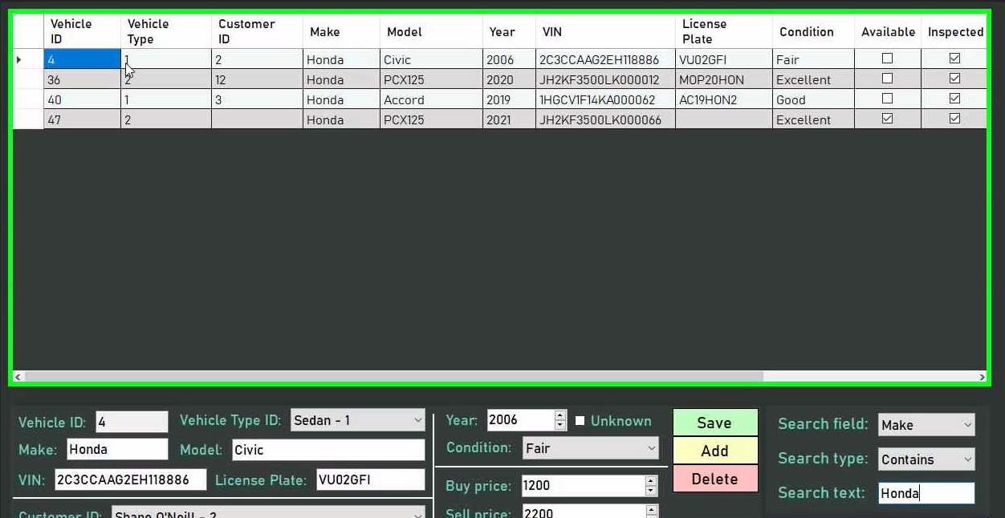
As you type into the search text field, you will find that the table automatically updates to match your query, thus allowing you to filter the database effectively.

CRUD operations (appointments)
Due to the rather distinct nature of the service appointments form, an additional section has been provided to guide mechanics in performing CRUD operations in the form.

Creating
To create a timeblock, you must first activate “Insert Mode.” This will clear any changes you made to the timetable and deselect any appointments, so ensure you are ready to do so.
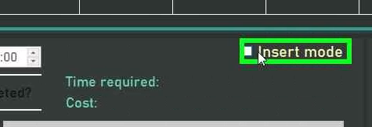

When you have activated “Insert Mode,” click on any free slot on the timetable. Note that you will be able to change the times later, so where you set it initially does not matter, but you must ensure the appointment is provided enough time to fit all of its services. Also note that you are not allowed to create appointments on your colleagues’ slots if you are not a lead mechanic.
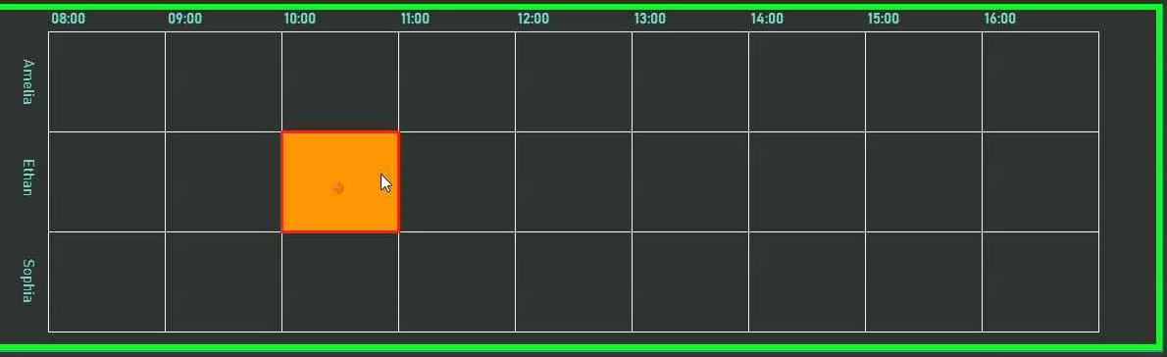

Once you have created the appointment, you may change the start and end times by either dragging and dropping the start or end of the appointment, or by using the provided NumericUpDown controls. Do note that these do not allow you to type times in.
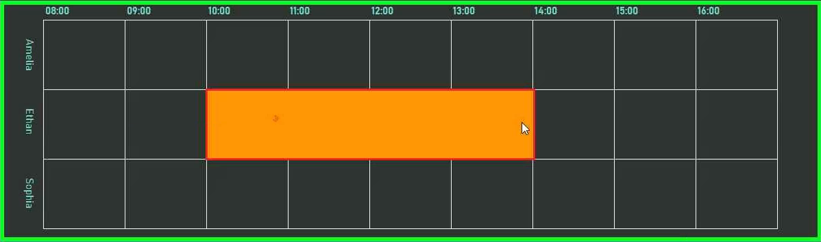
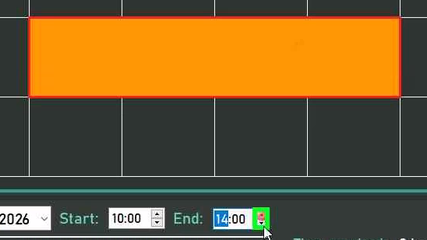

Once you are satisfied with the times, you will find that most of the fields are of a similar nature to the CRUD forms, so special focus will be made on the service and part selection system.

To select a service you wish to add on, simply double-click on it in the provided list. To deselect a service, simply click on it again. The service’s price and time will be added on to the running total, as displayed in the appropriate fields.

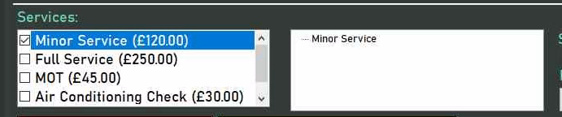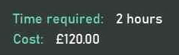
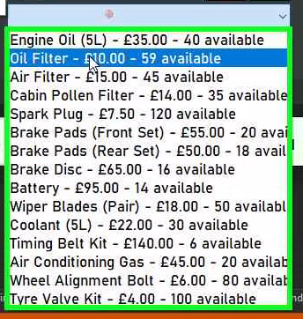
Some services may require parts. For these, select the service you wish to add parts to, and the part you wish to add on, and then click the “Plus” button to add and “Minus” button to subtract parts. Note that checks will be made to ensure that you do not exceed the part quantity stored in the part table, and the parts added on will be subtracted from the parts table upon creating the appointment.
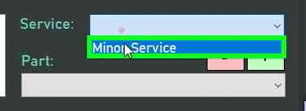
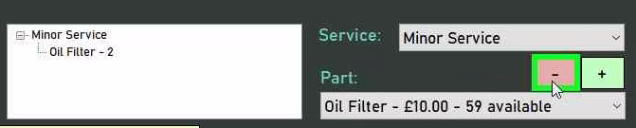
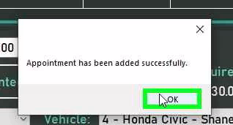
Once you are satisfied with the appointment details, click the “Add” button. If the appointment details are valid, the appointment will be added to the database as indicated by the orange timeblock turning blue.
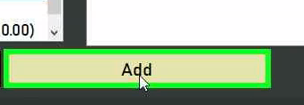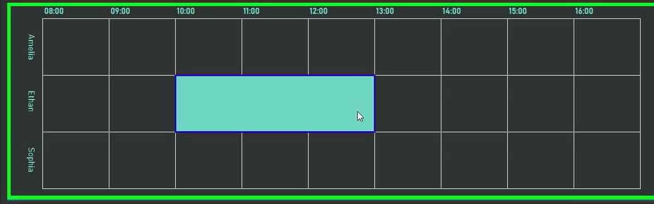
If at any point you wish to stop creating the timeblock, you may either disable “Insert Mode” or press the “Delete” button to delete the orange timeblock.
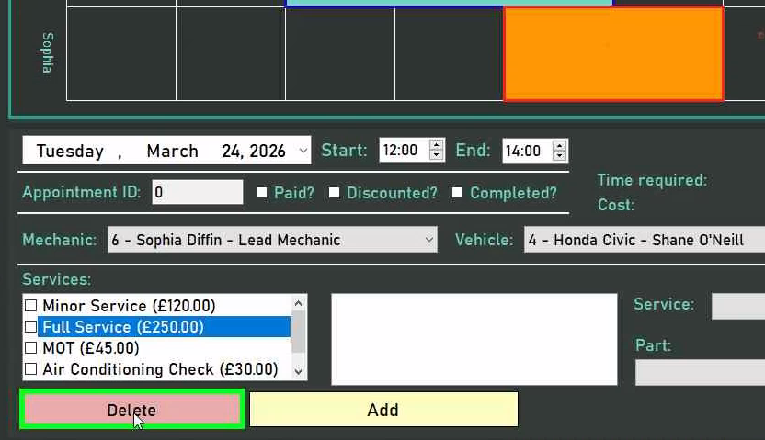

Reading
To access the timetable for a specific day, choose that day in the DateTimePicker provided. Once in the desired timetable, to view the details for a desired appointment, click on its timeblock representation. This will automatically populate its details into the appropriate fields.
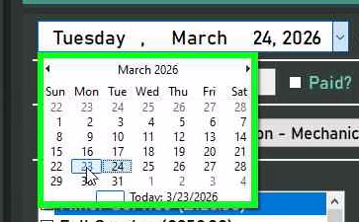
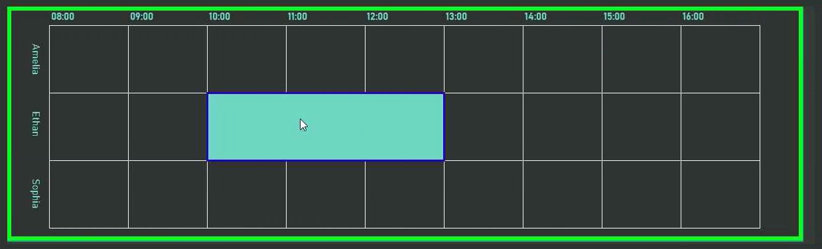
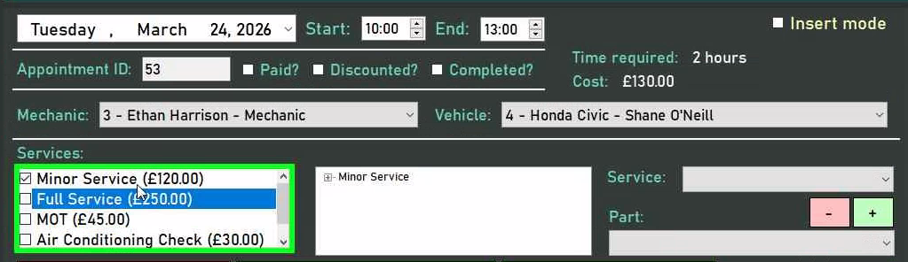

Updating
To update an appointment, select it by clicking on the timeblock representation, then modify the appointment’s details much in the same way as in the “Creating” section. Once you are satisfied with the appointment details, simply click the “Save” button. This will validate your appointment, and if all is deemed correct the new details will be stored in the database.
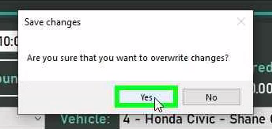
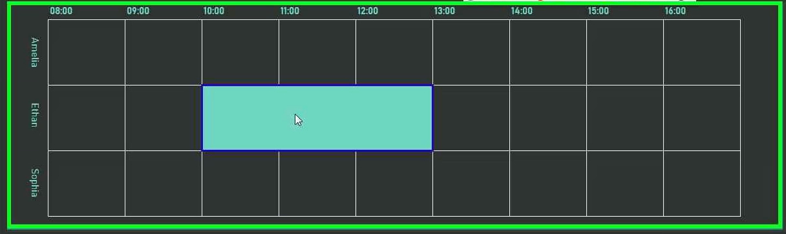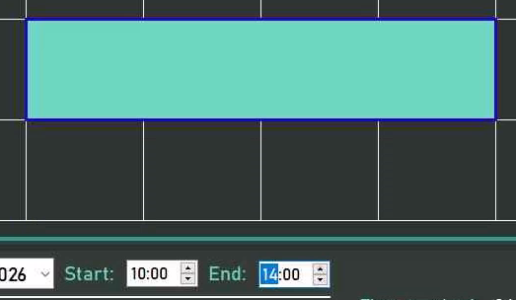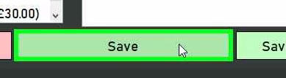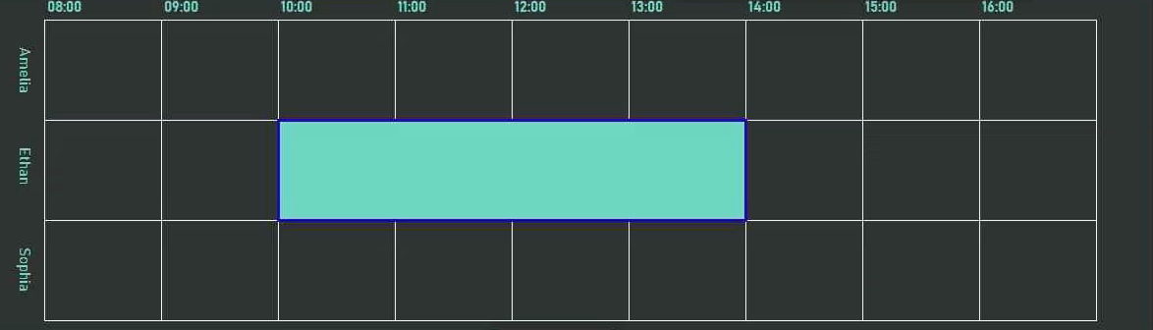

Updating Schedule
Updating a schedule undergoes much the same process as regular updating, except that only times will be saved for multiple appointments. To do this, first manipulate the relevant appointments to have the desired times, and then click the “Save New Schedule” button. If the times are valid, they will be saved to the database. Otherwise, you will be told which appointments need allocated more time.
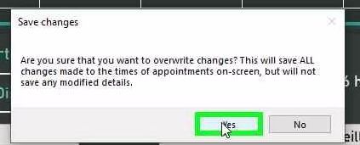
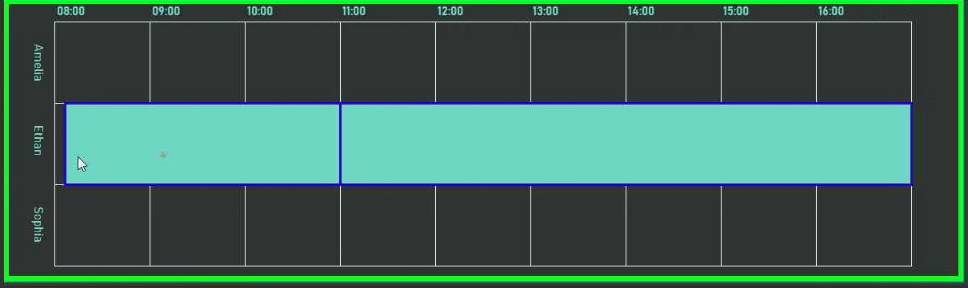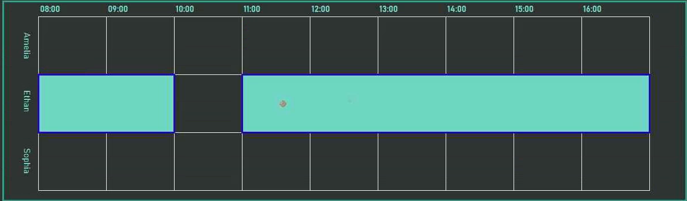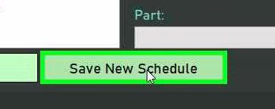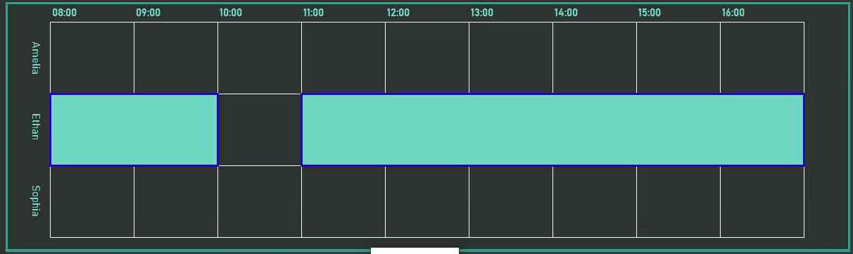

Deleting
To update an appointment, select it by clicking on the timeblock representation, then click the “Delete” button.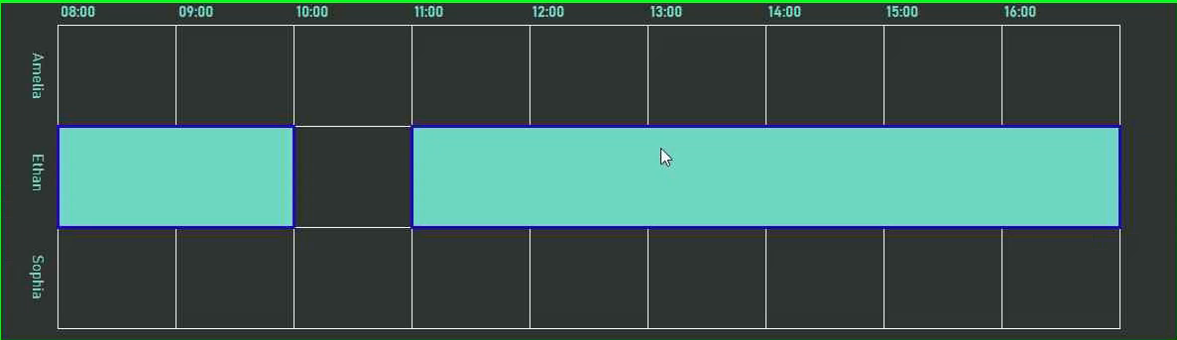

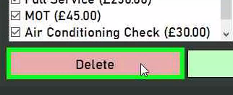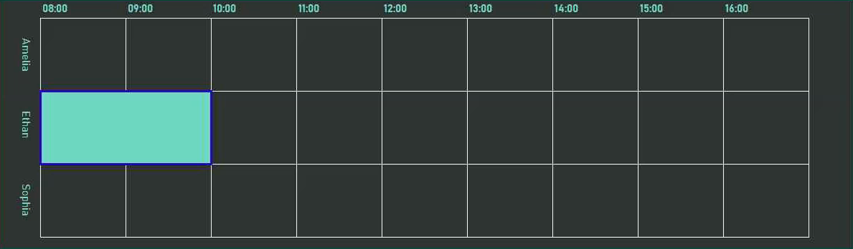

Searching
You may search for specific appointments using the allocated section. Here, 2 ComboBoxes have been provided: one for mechanics, and one for vehicles. If you wish to make a search more specific, you may select one of the available options in the ComboBoxes, otherwise you may leave them in their default state of “None.”
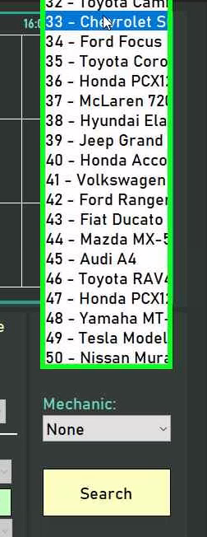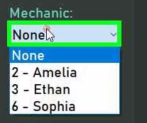
Once you are satisfied with the criteria, you may press the “Search” button to query the database with the provided filter. This will output a MessageBox displaying the details of all the appointments that match your search criteria if any were found.
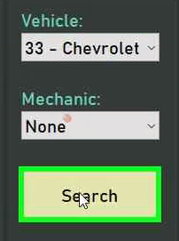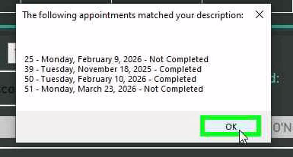

Reports

Changing reports
To change to a different report in the reports menu, simply click the tab with the name of the report you wish to access. This will automatically display the desired report with the most up-to-date information.
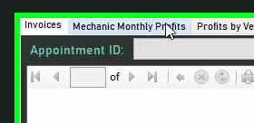
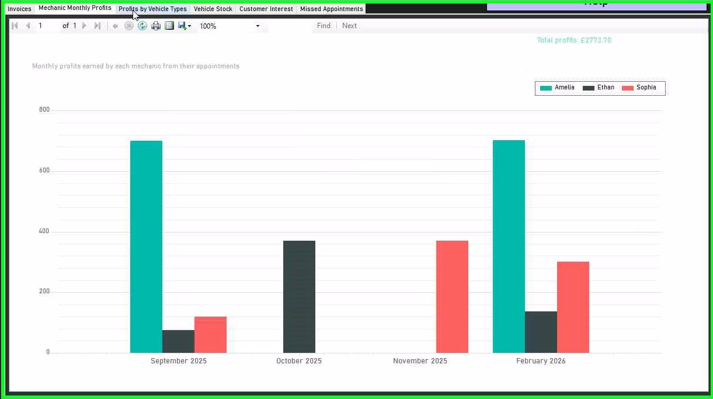

Printing reports
To print a report, click the printer icon seen in the toolbar at the top of the report.
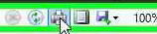

This will open the default system print dialog, from which you can select the printer with which you wish to print the report and any other settings. The specific details of this dialog depend on the system you are using, and thus will not be discussed further.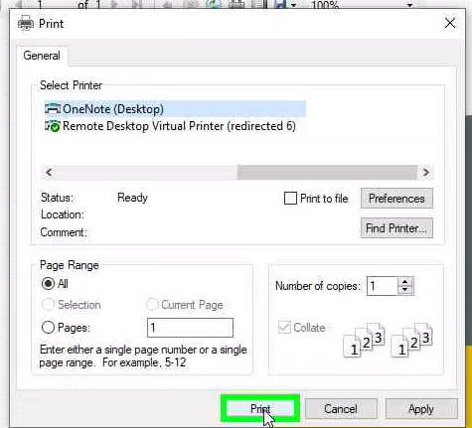

Logs

Filtering
The logs form provides 3 filtering options.

By default, the form displays the logs for the current day, but the log date can be selected using the DateTimePicker.
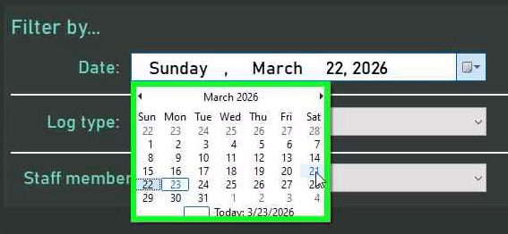
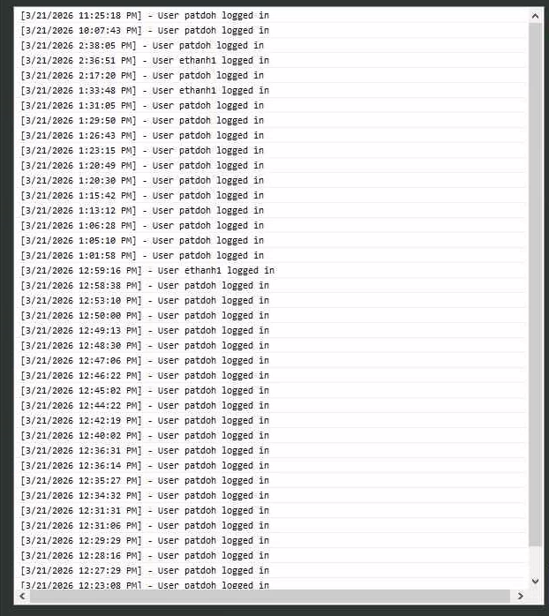
To further filter logs, the user can select the staff member associated with a log or the log type, both accommodated using ComboBoxes.
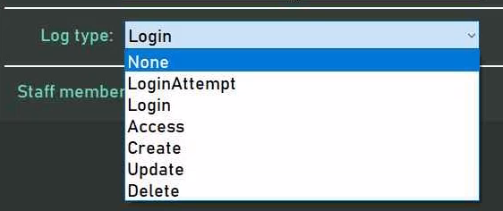
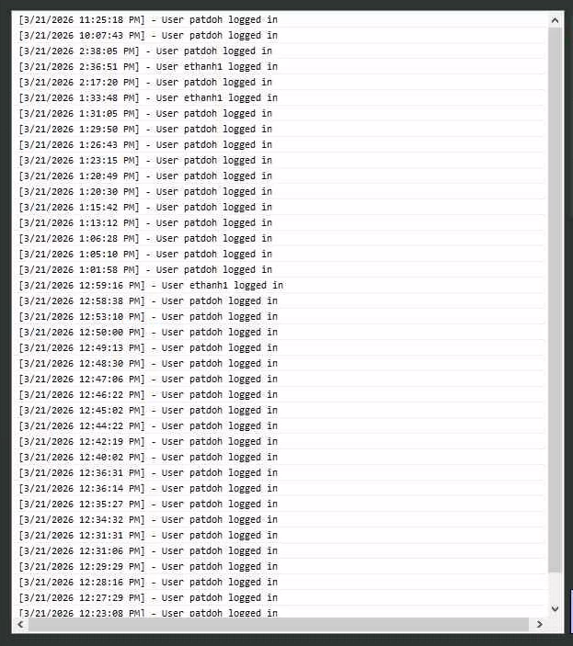
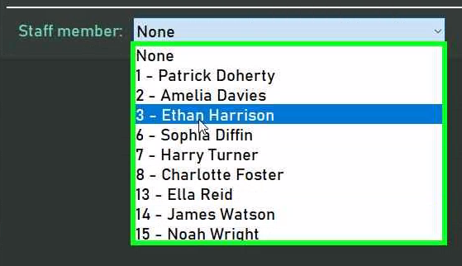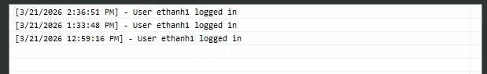

Logs can only be read to ensure integrity and accountability.

FAQ
- What does the password “hash” stored in the staff table mean?
A password hash is a one-way transformation of a password that lets the system verify it without ever storing the actual password, ensuring the security of the system
- What is a vehicle type’s “complexity”?
A vehicle type’s complexity is the scalar factor by which the duration of a service appointment is multiplied when a vehicle of that type is being serviced, aiming to ensure that more complex cars are given ample time to be serviced thoroughly.
- What is a role’s “authorisation level”?
A role’s authorisation level denotes the level of access which a user of that role has in the system. It does not denote which forms they can access - that is the job of the sector - and presently has 3 values: 0, representing read-only, where a user can only read and not modify record; 1, representing restricted write, where a user has permission to make changes to less crucial data on the system, but is restricted from performing more critical tasks; and 2, representing unrestricted write, where the user has unrestricted access to operations on the data present in the database.
- Why has _____ not been implemented yet?
Time.
- What do I do in the event of an error?
A number of help forms have been provided which aim to guide you if the event is a result of any behaviour that is unique to that form. If the help form does not help you, contact the administrator or a member of the IT department.
- How do I add on more mechanics / how do I modify the working hours for mechanics?
It is currently assumed that the number of 3 mechanics will remain the same in the foreseeable future, and likewise for working hours, and as such only editing the source code will allow you to modify the parameters of the appointment viewer. Note that the appointment viewer was designed to be dynamic, and so should respond to such change appropriately, but technical knowhow is still required to make these changes.
- Why are my changes not saving to the database?
Changes may not be saved to a database either because of the use of the “Debug” compilation option, or system error preventing data from being saved. Either way, more thorough investigation on your end will be required.
- What are the log types on the system?
At the moment, to reflect the current operations available to the user on the system, the log types available are unsuccessful login attempts (LoginAttempt), successful logins (Login), accessing forms (Access), creating new data (Create), updating existing data (Update), and deleting existing data (Delete.) These are not final, and may be amended in the future as more functionality is added.

